SCHOOL OF CYBERSECURITY
NAME: OBASI CHARLES CHIDOZIE
ID: VEPH/20B/CY053
TASK: TASK 20B (LESSON 20)

Technical Cyber security Report

Analysis Using Splunk for Security Log Management and Dashboard Creation

By

Cyber Security Personnel : OBASI CHARLES CHIDOZIE

Date : 7/04/2025

Stakeholders : VEPHLA SECURITY TEAM

REPORT OUTLINE

Outline of all pages within technical report

- Executive Summary
- Brief overview of the entire report
- Key findings and recommendations
- Background and purpose
- Scope/aim & Objectives of the report
- Objectives of tools used (Splunk)
- Methodology
- Step-by-step process followed
- Tools configuration and execution
- Findings and Analysis
- Behavioral Analysis
- Observations during scanning
- Risk and Impact Assessment
- Potential impacts on systems or networks
- Recommendations
- Immediate Remediation Actions
- Mitigation Strategies
- Conclusion
- Summary of findings

1. Executive Summary
- Overview:
The analysis with splunk was conducted as part of a security log management of the host system. The tool successfully provided insights into the system’s security log and created a dashboard to detect or scan for unauthorised access into the system. This report carries details of how Splunk Enterprise installation as a robust security information and event management (SIEM) tool analyze Windows Event Viewer security logs. Starting with log clearing, followed by analysis and creating essential visualization to assist in developing better security protocols for the organization.
- Key Findings:
  - Splunk successfully analyzed and captured system events logs and visualized them on a custom dashboard.
  - Clearing of the target systems security logs registered the Event ID 1102, which was logged and detected.
  - Login attempts (both successful and failed) were visualized through Event IDs 4624 and 4625, providing insight into the user's activity.

2. Background and Objectives
- Project Context:
  - The aim of this project is to enhance security monitoring capabilities by implementing Splunk to scan for, collect, analyze, and visualize Windows Event Viewer security logs. This will enable real-time monitoring, detection of possible threat and vulnerability as a result of unauthorized access, compliance reporting and improved incident response.

- Objective of the Tool Use:
Splunk was used for;
  - Identifying Windows Event Viewer log files before processing their content.
  - Visualizing key security events on the target system.
  - Continuous monitoring functions in real-time were established through custom dashboard construction that ran alerts .

3. Methodology

3.1 Tool Configuration
- Downloading Splunk:
  - Visit the Splunk official website via “https://www.splunk.com”
  - Click on Products and select Free Trials & Downloads.
  - Under Splunk Enterprise, click Get My Free Trial.
  - Sign up/log in to download Splunk Enterprise (Free Trial for local machines)

- Installing Splunk:
  - Run the downloaded file.
  - Accept the licensing agreement.
  - Select Local System Account for installation.
  - Set admin username and password. (Be sure to remember it).
  - Choose the installation directory (default: C:\Program Files\Splunk).
  - Run the Windows Installer on the target system and wait for the installation to complete.
  - Choose the default port.
  - Start Splunk and access via Login | Splunk http://127.0.0.1:8000/en-US/account/login

- Enabling Windows Event Log Input:
  - Sign into splunk
  - Navigate to Settings > Data Inputs.
  - Add new input for Local Event Logs.
  - Add applications, Security, and System as selected log channels and save.

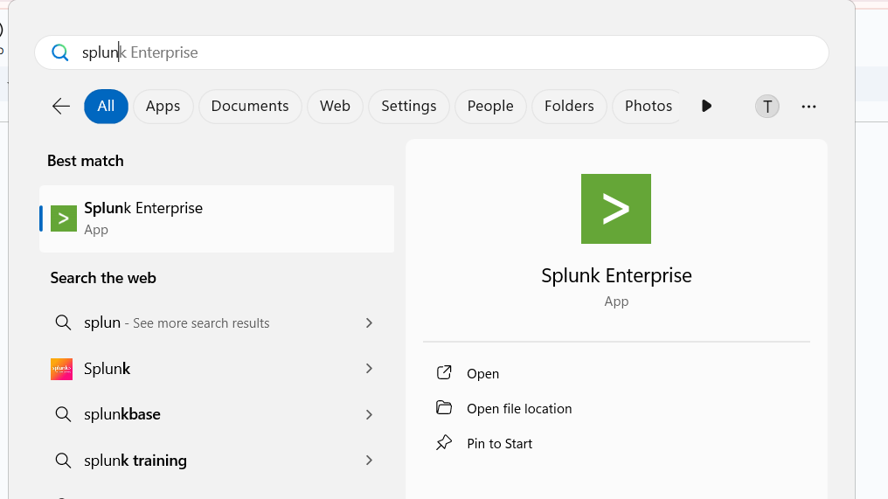

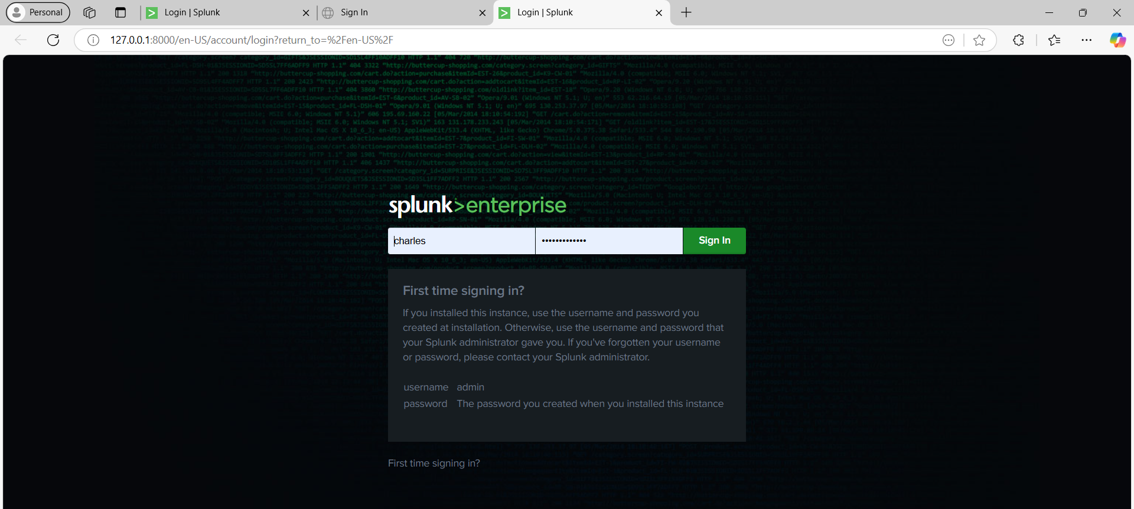

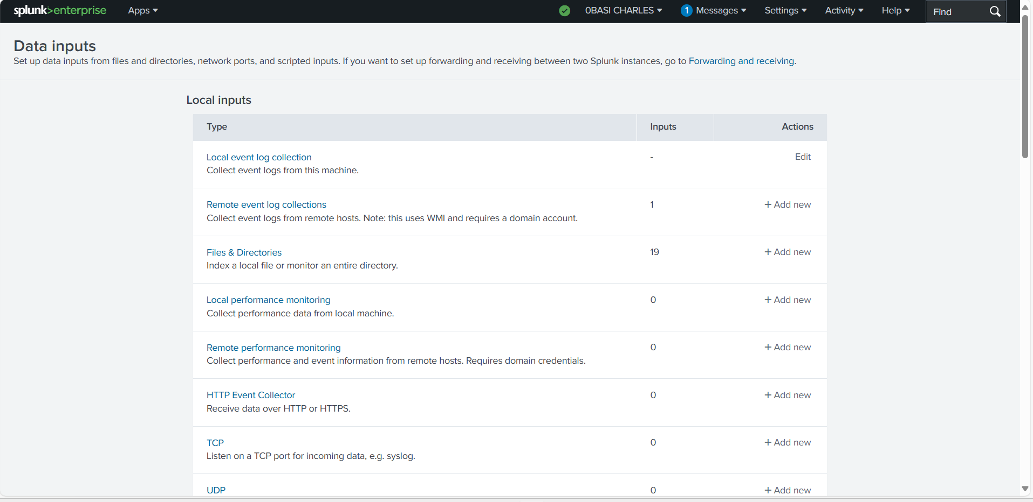

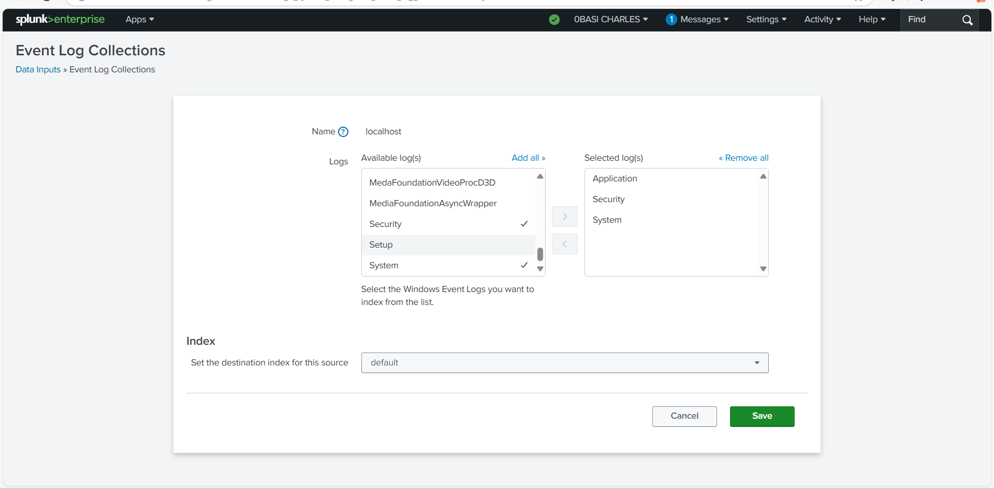
- Clear Event Viewer Security Logs
Open Event Viewer:
  - Press the Window button, and search for event viewer, and hit Enter.
  - Navigate to Windows Logs > Security.
Clearing system Logs:
  - Right-click on Security and select Clear Log.
  - Confirm the action to clear all events.
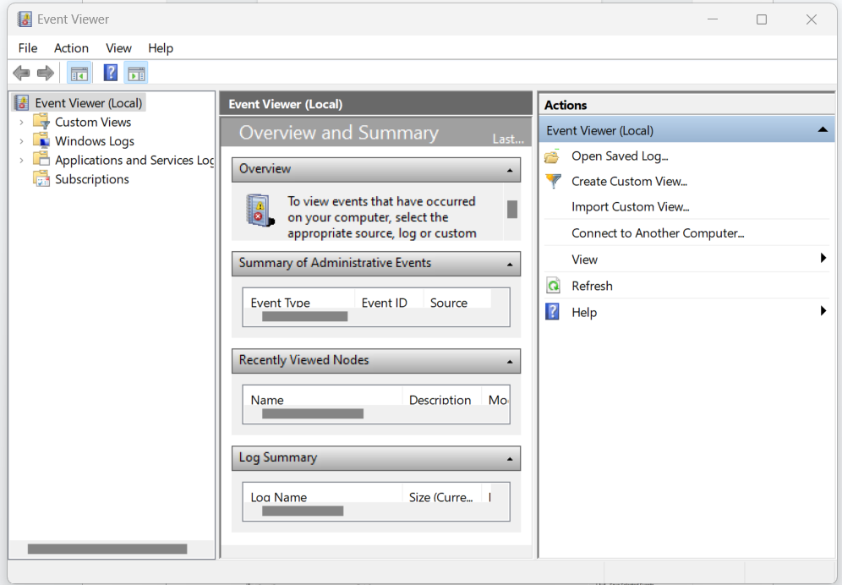

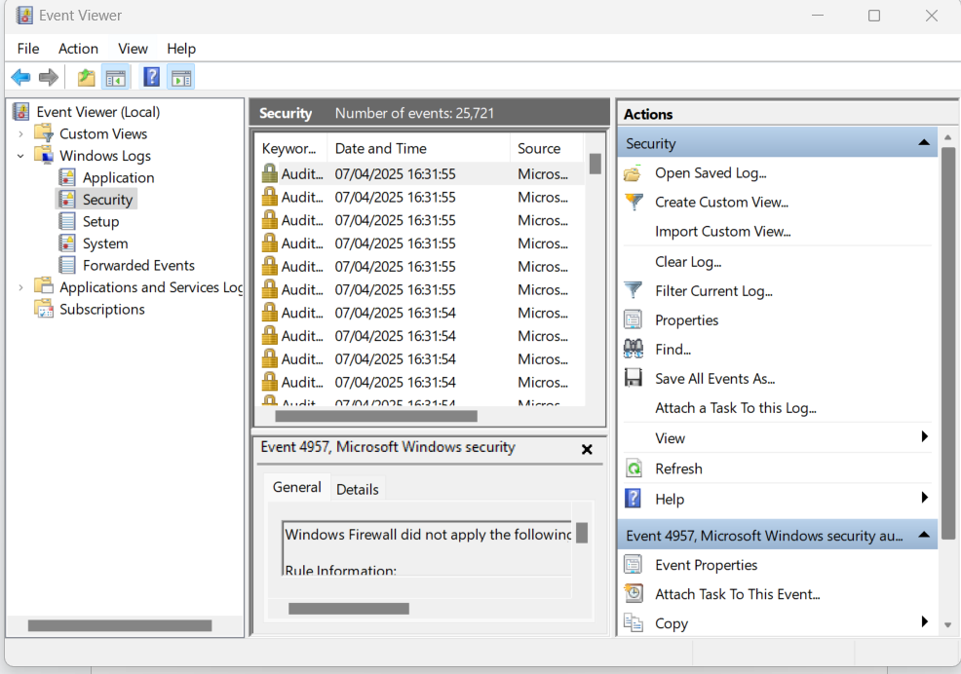

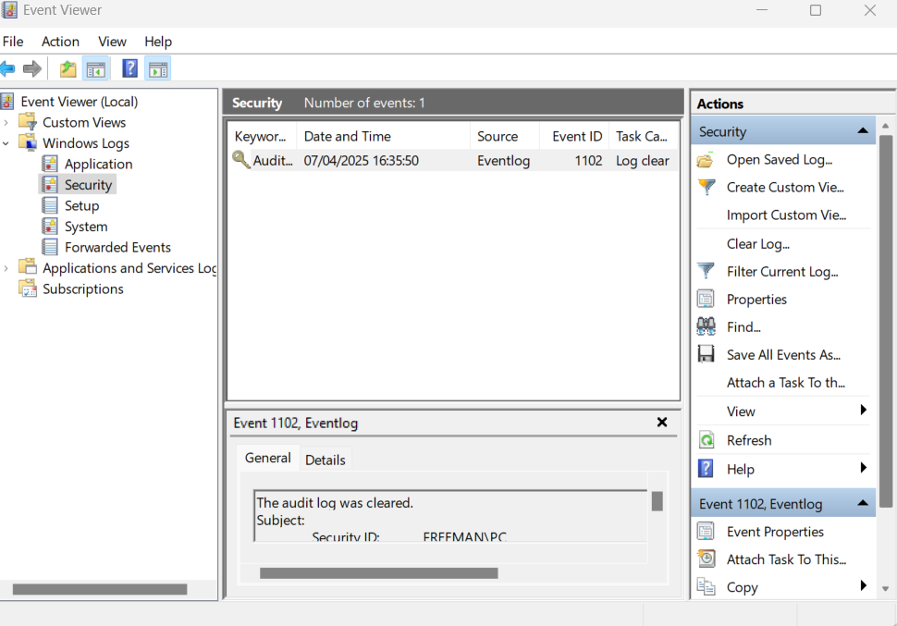

3.2 Execution Process
- Applying advanced search filter execution in Splunk
  - Open Splunk Enterprise and navigate to Search & Reporting.
  - Navigate and click on “search and reporting” on the home page of Splunk
  - To get Logs, type the “*” button on the search bar, adjust the time frame, and hit the enter button to get information about events
  - Left-click on the device name which is the host to add to the search
  - Left-click on the “WinEventLog: Security” that serves as the source to be added to the search
  - Left-click on the “Eventcode” to filter events by code
  - Visit https://www.ultimatewindowssecurity.com/securitylog/encyclopedia/default.aspx to get the event code for the audit log clear.
  - Use the event code to get records of events that happened on Splunk.
  - Confirm logs are being ingested by checking for recent events.

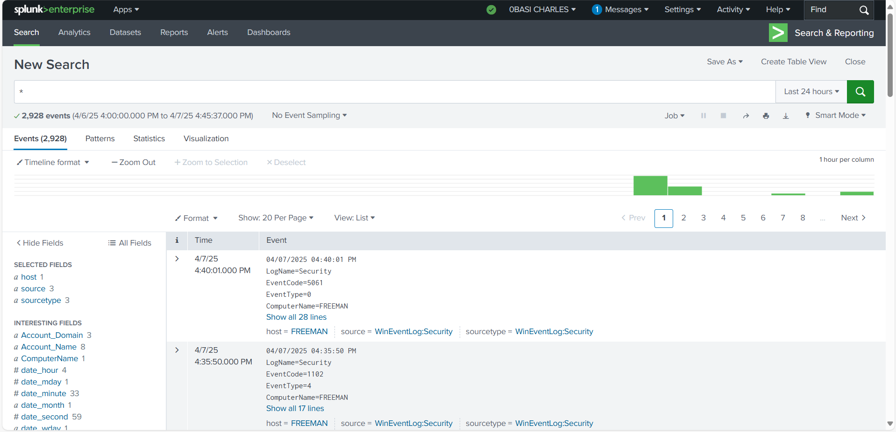

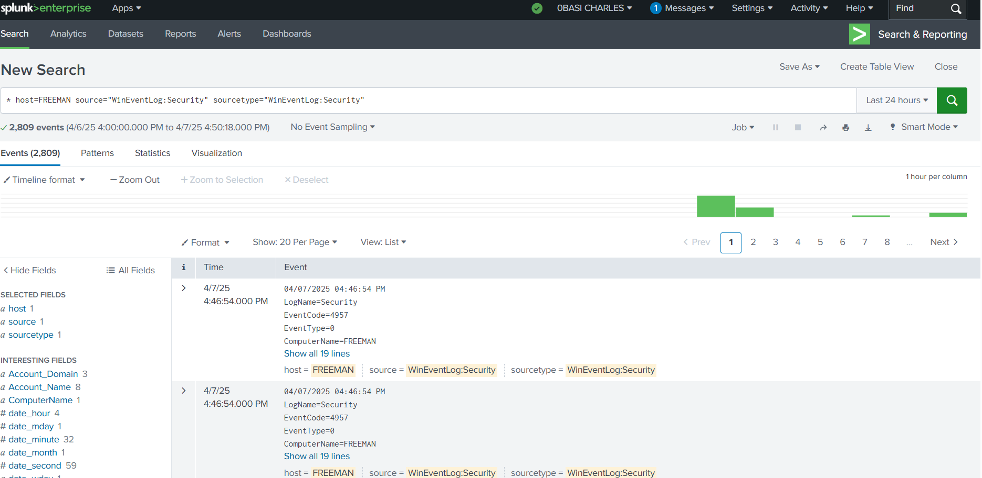

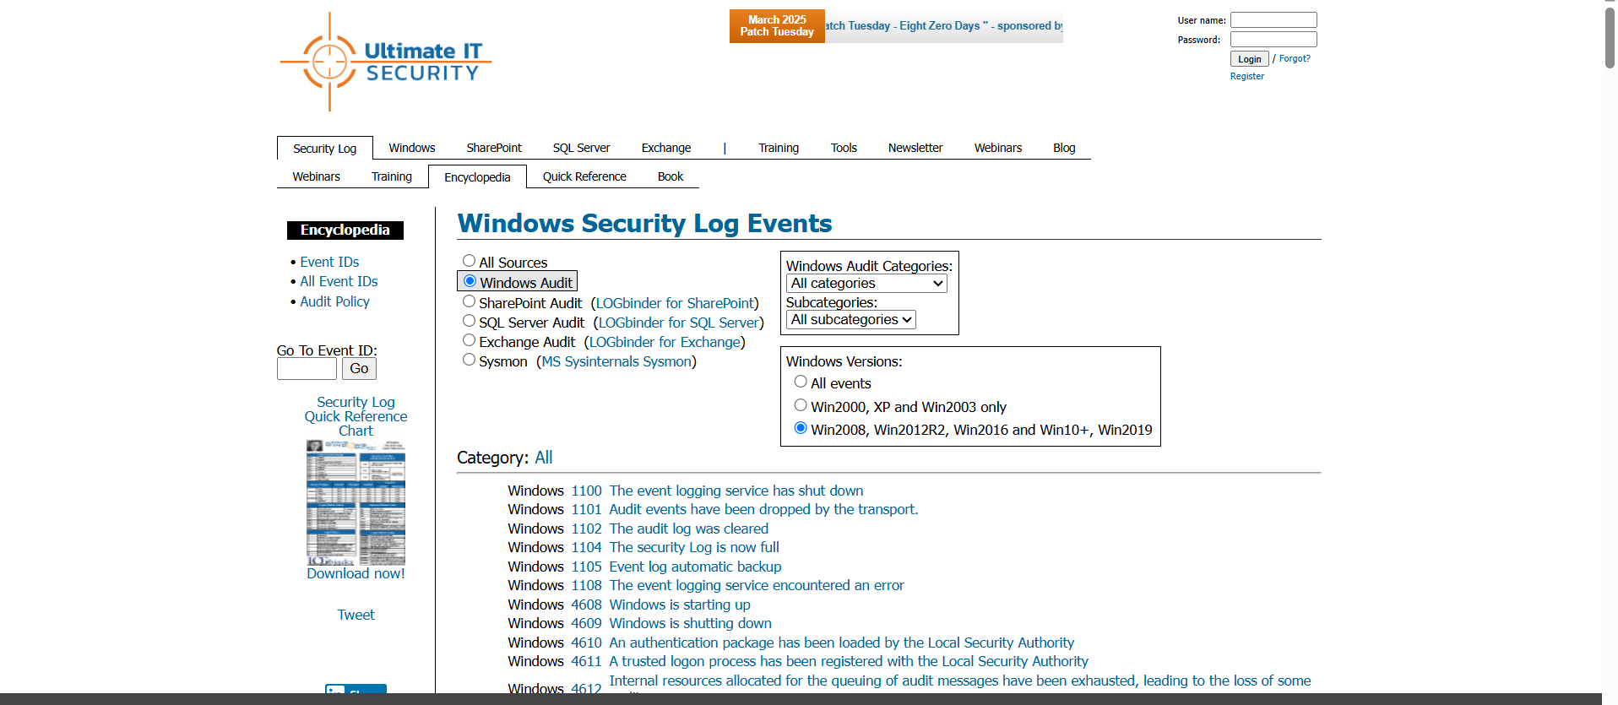

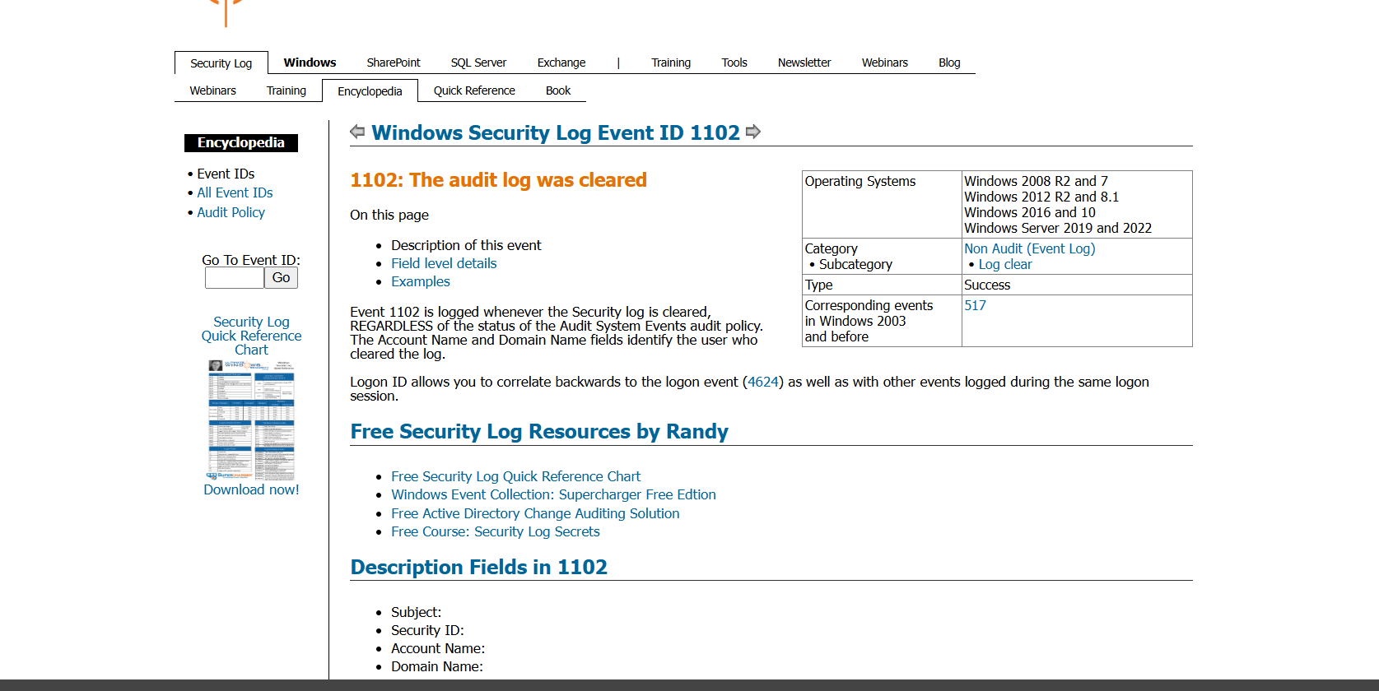

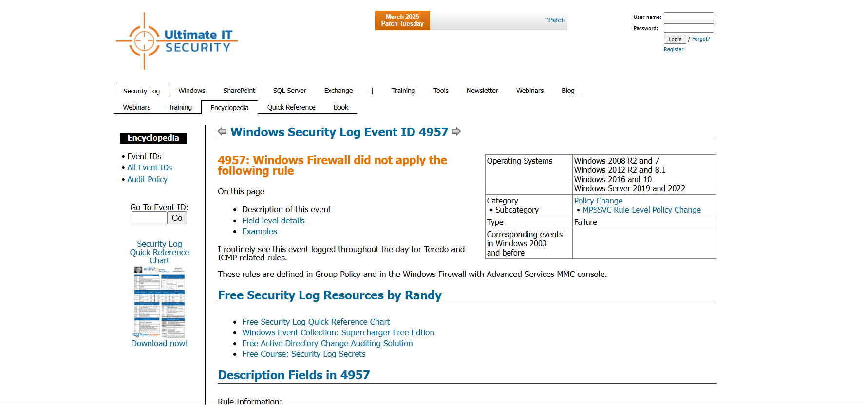
Creating a Dashboard in Splunk:
1. Open Splunk, navigate to Dashboards.
2. Click Create New Dashboard.
3. Provide a dashboard name and description, then click Create.
4. Add panels:
• Use the Search & Reporting feature to generate logs.
• Click Save As → Dashboard Panel to add logs to your dashboard.
• Customize visualizations (tables, charts, graphs).
5. Click Save, then go to Dashboards to view real-time log data.

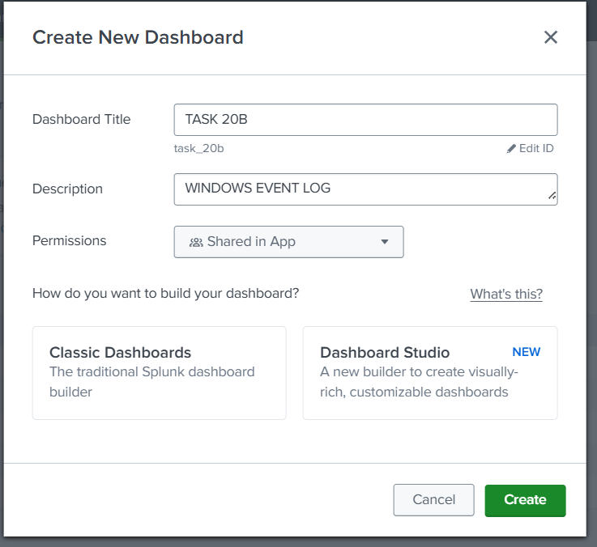

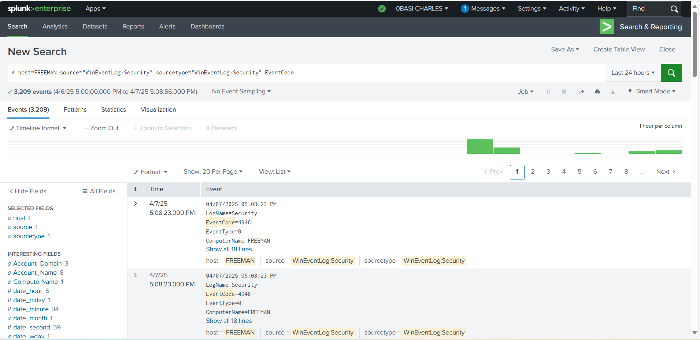

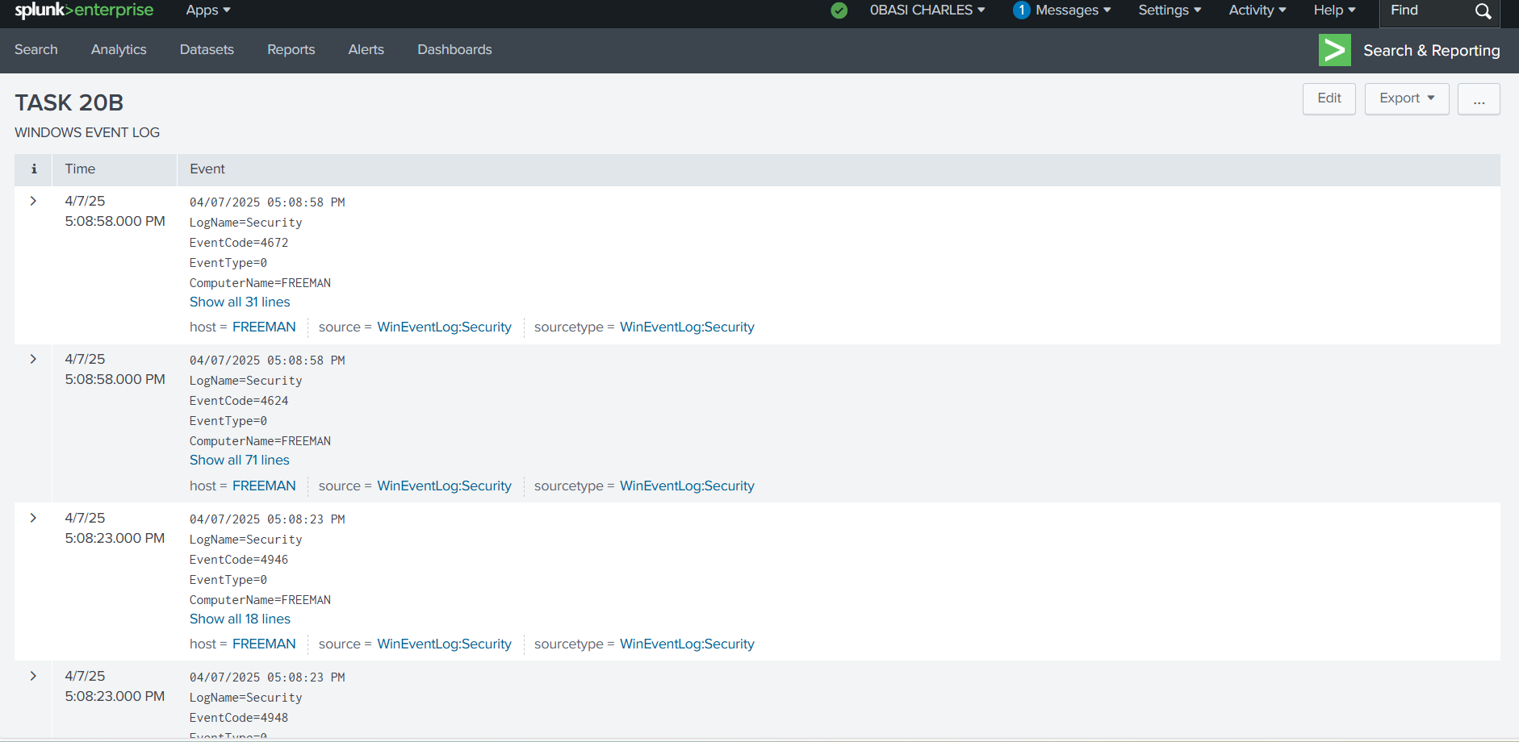

3.3 Monitoring and Analysis:
- System Monitoring:
Splunk parsed system events including login activities and log clearance

4. Findings and Analysis

4.1 Indicators of Compromise (IOCs):

Indicator Type | Value
Event ID | 1102 (Security Log Cleared)

Detected IOCs:
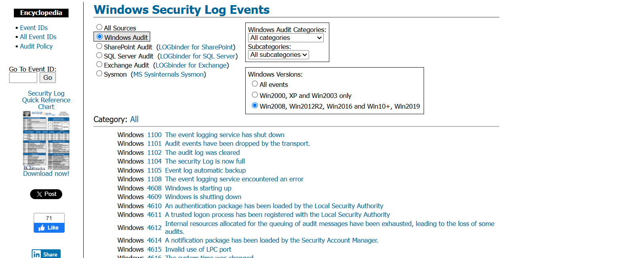

4.2 Behavioral Analysis:
- Actions observed:
• Splunk captured and logged the security log Event with ID 1102
• User login activities were captured and categorized by outcome (success/failure)
• A system user manually cleared the Security log as was captured by splunk.
No malware was detected

4.3 Risk and Impact Assessment:
- Potential Impact:
  - Poor management and analysis of system security logs could hinder the detection of possible malware activities on the target system. This inturn, creates ron for possible vulnerabilities and compromise.

5. Recommendations

5.1 Immediate Remediation Actions:
  - Alerts for Event ID 1102 should be enabled so as to detect log clearance attempts
  - Restrict access to event logs to only administrators or authorised personnels to minimize unauthorized clearing of security logs.
  - Splunk should be monitored in real time to ensure quick detecting of a suspicious event log.

5.2 Long-Term Mitigation:
- Security Measures:
  - Splunk Should be Integrated With other security tools and other devices to capture logs for comprehensive security monitoring.
  - Identify unusual login behavior.
  - Train users to report login anomalies.
- Monitoring and Detection Enhancements:
  - Schedule frequent reviews of Splunk dashboards for detection of unauthorised logs.

6. Conclusion
- Summary of Findings:
  - Splunk Enterprise was successfully installed and effectively configured to monitor and visualize Windows Event Viewer security logs.
  - Clearing the initial logs provided a clean baseline for monitoring new security events.
  - A basic dashboard was created to visualize key security activity.
  - The tool’s real-time visibility allowed the identification of key risk indicators from Windows Event Logs.
- Next Steps:
  - Apply detection rules and alerts to flag any log suspicious or unauthorized log clearing activities
  - Use splunk dashboards to monitor critical system behaviors in real time.
  - Integrate Splunk with other security tools for comprehensive monitoring.
  - Train personnel to interpret Splunk alerts and dashboards efficiently

Appendix: Additional Data
- Raw Logs and Tool Outputs:

